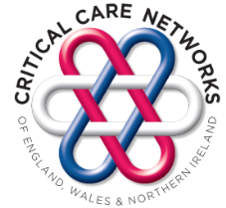
Critical Care Networks of England,
Wales and Northern Ireland

National Critical Care Networks AGM

Monday 27th April 2020

NETWORK ATTENDANCE FORM
The Studio - Escape Room. 7 Cannon Street, Birmingham, B2 5EP

Meeting 10.30 am – 3.30 pm with registration and refreshments from 10.00 am

Network Directors/Managers should complete and return this form listing the details of their representative team members. Forms should be returned to Dorothy Bailey Lancashire & S Cumbria Critical Care ODN Administrator at: Dorothy.Bailey@lthtr.nhs.uk by Friday 27th March 2020.

NB. It is the responsibility of attendees to inform Dorothy Bailey of any changes prior to the event.

Please complete all fields and print your details clearly.

Network

Network Director/Manager Name

Contact telephone number

Contact e-mail address

Attendees | Job Title | Contact e-mail | Any special dietary or other requirements

1.

2.

3.

4.

5.

Please ensure that you have included contact details as members will receive notification of registration. Confirmation e-mails will be sent by return.

If you have any queries regarding this event please contact Dorothy on 01772 524475

Organising team use only
Date form received from Network
Date confirmation sent to attendees

